Enneagrammic Rotunda
# Source: AI Source: Provided by: [Data Path: Persons Table -> ID Column: 1, Name_En Column: Motasem Essam] -> From: [ChatGPT] on [7/25/2026]
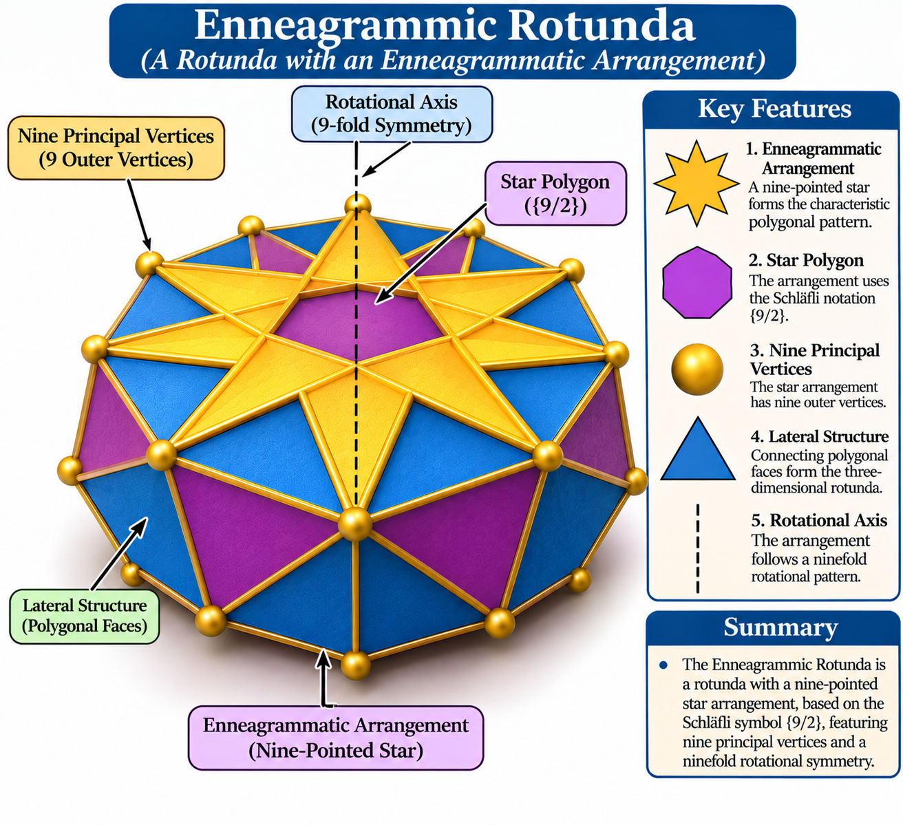

Definition
# Source: AI Source: Provided by: [Data Path: Persons Table -> ID Column: 1, Name_En Column: Motasem Essam] -> From: [ChatGPT] on [7/25/2026]
An Enneagrammic Rotunda is a star-rotunda-type polyhedron characterized by an enneagrammatic arrangement, which is a nine-pointed star.
The documented example is specifically identified by the star-polygon notation $\{9/2\}$, meaning that its nine vertices are connected by skipping one vertex at each step. <Cite refs={["turn336288search7","turn336288search12"]}/>
It belongs to the Star-Rotunda family and is distinct from an ordinary Nonagonal Rotunda.

Geometric Structure
# Source: AI Source: Provided by: [Data Path: Persons Table -> ID Column: 1, Name_En Column: Motasem Essam] -> From: [ChatGPT] on [7/25/2026]
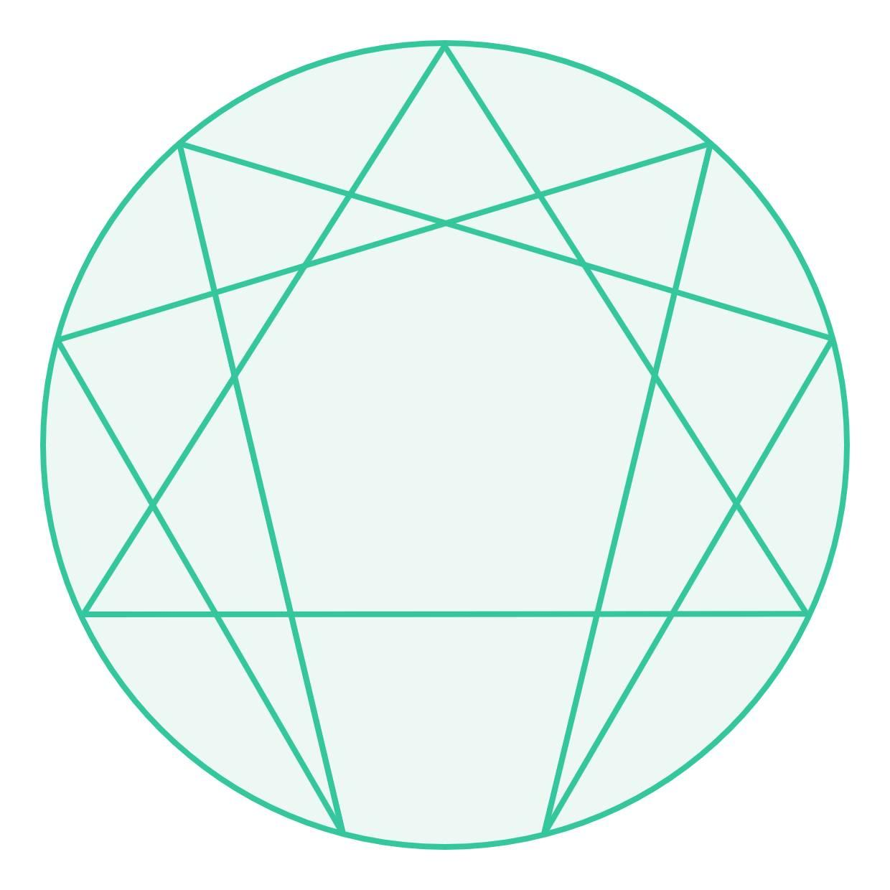
Its defining geometric structure includes:
- Enneagrammatic Arrangement: A nine-pointed star forming the characteristic polygonal pattern.
- Star Polygon: The arrangement uses the Schläfli notation $\{9/2\}$.
- Nine Principal Vertices: The star arrangement has nine outer vertices.
- Lateral Structure: Connecting polygonal faces form the three-dimensional rotunda structure.
- Rotational Axis: The arrangement follows a ninefold rotational pattern.

Geometric Characteristics
# Source: AI Source: Provided by: [Data Path: Persons Table -> ID Column: 1, Name_En Column: Motasem Essam] -> From: [ChatGPT] on [7/25/2026]
- Solid Type: Star-rotunda-type polyhedron.
- Defining Star Polygon: Enneagram.
- Schläfli Symbol: $\{9/2\}$.
- Principal Vertices: 9.
- Rotational Symmetry: Ninefold.
- Geometric Nature: Star-shaped construction.
- Convexity: Non-convex or intersecting geometry may occur in star-polyhedron constructions.
- Face Composition: Based on the particular three-dimensional construction.
- Mathematical Counts: No universal face, edge, or vertex counts are assigned here.

Construction of Enneagrammic Rotunda

Geometric Instruments Used
# Source: AI Source: Provided by: [Data Path: Persons Table -> ID Column: 1, Name_En Column: Motasem Essam] -> From: [ChatGPT] on [7/25/2026]
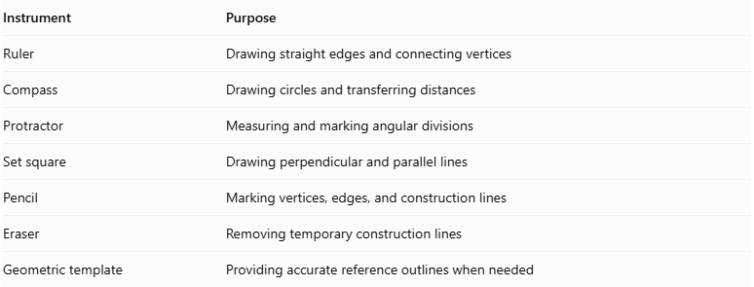
Instrument | Purpose
Ruler | Drawing straight edges and connecting vertices
Compass | Drawing circles and transferring distances
Protractor | Measuring and marking angular divisions
Set square | Drawing perpendicular and parallel lines
Pencil | Marking vertices, edges, and construction lines
Eraser | Removing temporary construction lines
Geometric template | Providing accurate reference outlines when needed

Instrument-Based Construction Procedures

Constructing the Regular Nonagonal Reference
# Source: AI Source: Provided by: [Data Path: Persons Table -> ID Column: 1, Name_En Column: Motasem Essam] -> From: [ChatGPT] on [7/25/2026]
- Draw a circle using a compass.
- Mark its center $O$.
- Divide the circumference into nine approximately equal angular sections using a protractor.
- Mark the nine points $A,B,C,D,E,F,G,H,I$ in circular order.
- Check that the points are equally spaced around the circle.
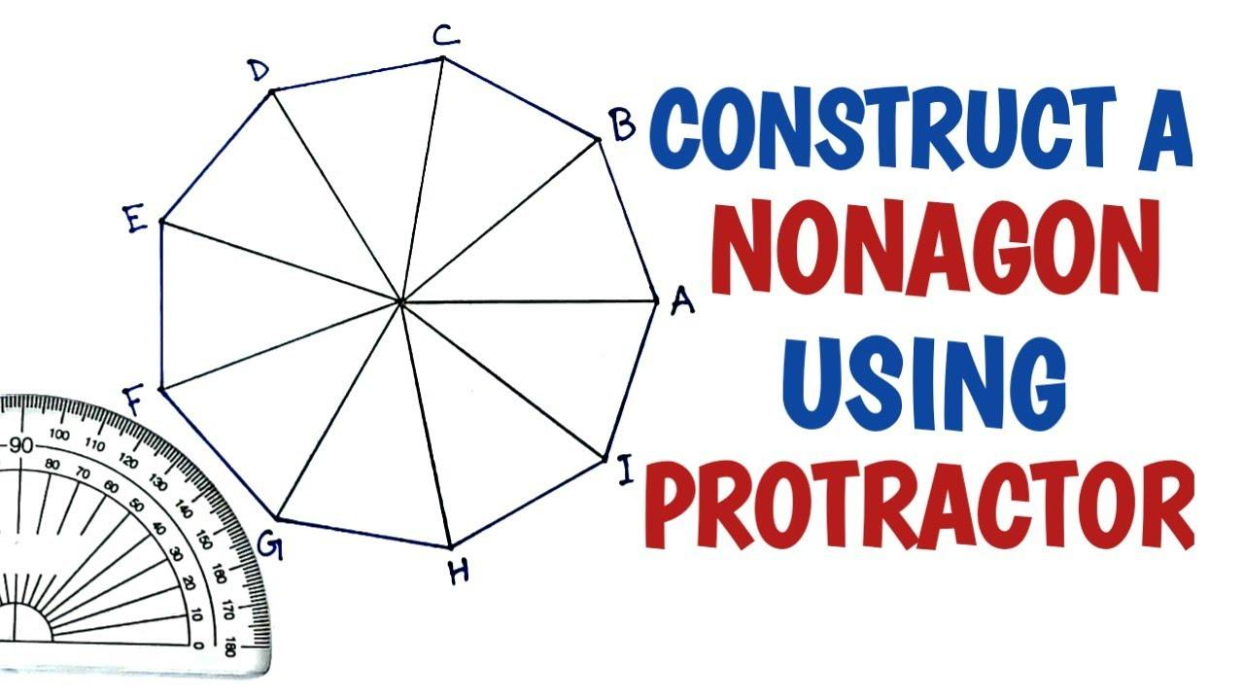
Angular measurement:
$$θ=\frac{{360}^{°}}{9}={40}^{°}$$
Construction limitation: A regular nonagon cannot be constructed exactly using only a compass and an unmarked straightedge. A protractor or geometric template can be used for a measured or approximate construction.

Constructing the Enneagram
# Source: AI Source: Provided by: [Data Path: Persons Table -> ID Column: 1, Name_En Column: Motasem Essam] -> From: [ChatGPT] on [7/25/2026]
The documented enneagram is the $\{9/2\}$ star polygon.
- Start at vertex $A$.
- Connect $A$ to $C$.
- Connect $C$ to $E$.
- Connect $E$ to $G$.
- Connect $G$ to $I$.
- Connect $I$ to $B$.
- Connect $B$ to $D$.
- Connect $D$ to $F$.
- Connect $F$ to $H$.
- Connect $H$ back to $A$.
This creates a continuous nine-pointed star.
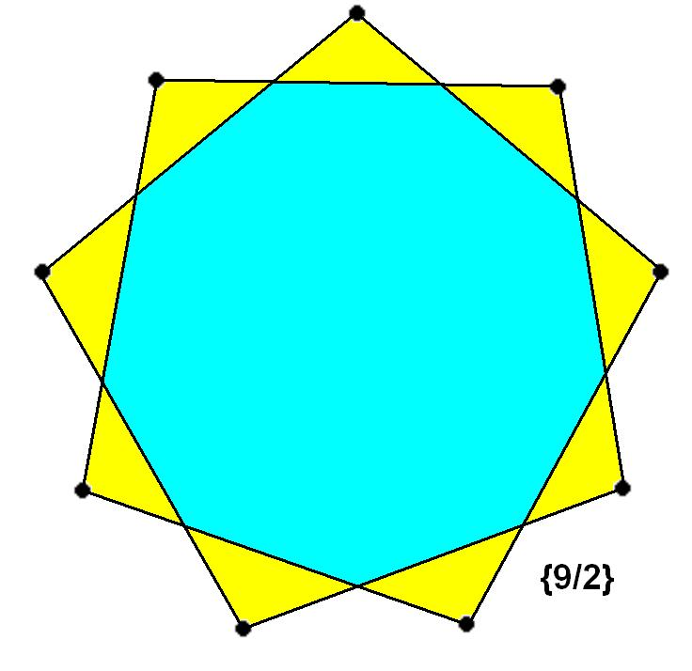
Star-polygon angular step:
$$θ_{s}=2({40}^{°})={80}^{°}$$

Constructing the Parallel Arrangement
# Source: AI Source: Provided by: [Data Path: Persons Table -> ID Column: 1, Name_En Column: Motasem Essam] -> From: [ChatGPT] on [7/25/2026]
- Draw a second construction plane parallel to the first.
- Mark its center.
- Reproduce the nine-point reference arrangement.
- Maintain the intended orientation and relative alignment between the two arrangements.
- Check the spacing and positioning of the corresponding vertices.

Establishing the Central Axis
# Source: AI Source: Provided by: [Data Path: Persons Table -> ID Column: 1, Name_En Column: Motasem Essam] -> From: [ChatGPT] on [7/25/2026]
- Identify the center of the upper arrangement.
- Identify the center of the lower arrangement.
- Draw a perpendicular line passing through both centers.
- Extend the line to represent the central axis.
- Use this axis as the reference for the solid's rotational arrangement.

Connecting the Upper and Lower Arrangements
# Source: AI Source: Provided by: [Data Path: Persons Table -> ID Column: 1, Name_En Column: Motasem Essam] -> From: [ChatGPT] on [7/25/2026]
- Identify the corresponding vertices in both arrangements.
- Connect the vertices according to the Enneagrammic Rotunda reference model.
- Draw the required lateral edges using a ruler.
- Establish the boundaries of the lateral faces.
- Check that the connections reproduce the reference model without adding arbitrary edges.

Completing the Solid Representation
# Source: AI Source: Provided by: [Data Path: Persons Table -> ID Column: 1, Name_En Column: Motasem Essam] -> From: [ChatGPT] on [7/25/2026]
- Complete the upper and lower star-shaped boundaries.
- Complete the lateral face outlines.
- Draw visible edges using continuous lines.
- Draw hidden edges using dashed lines.
- Erase unnecessary construction lines.
- Label the star arrangements, lateral faces, vertices, and central axis.
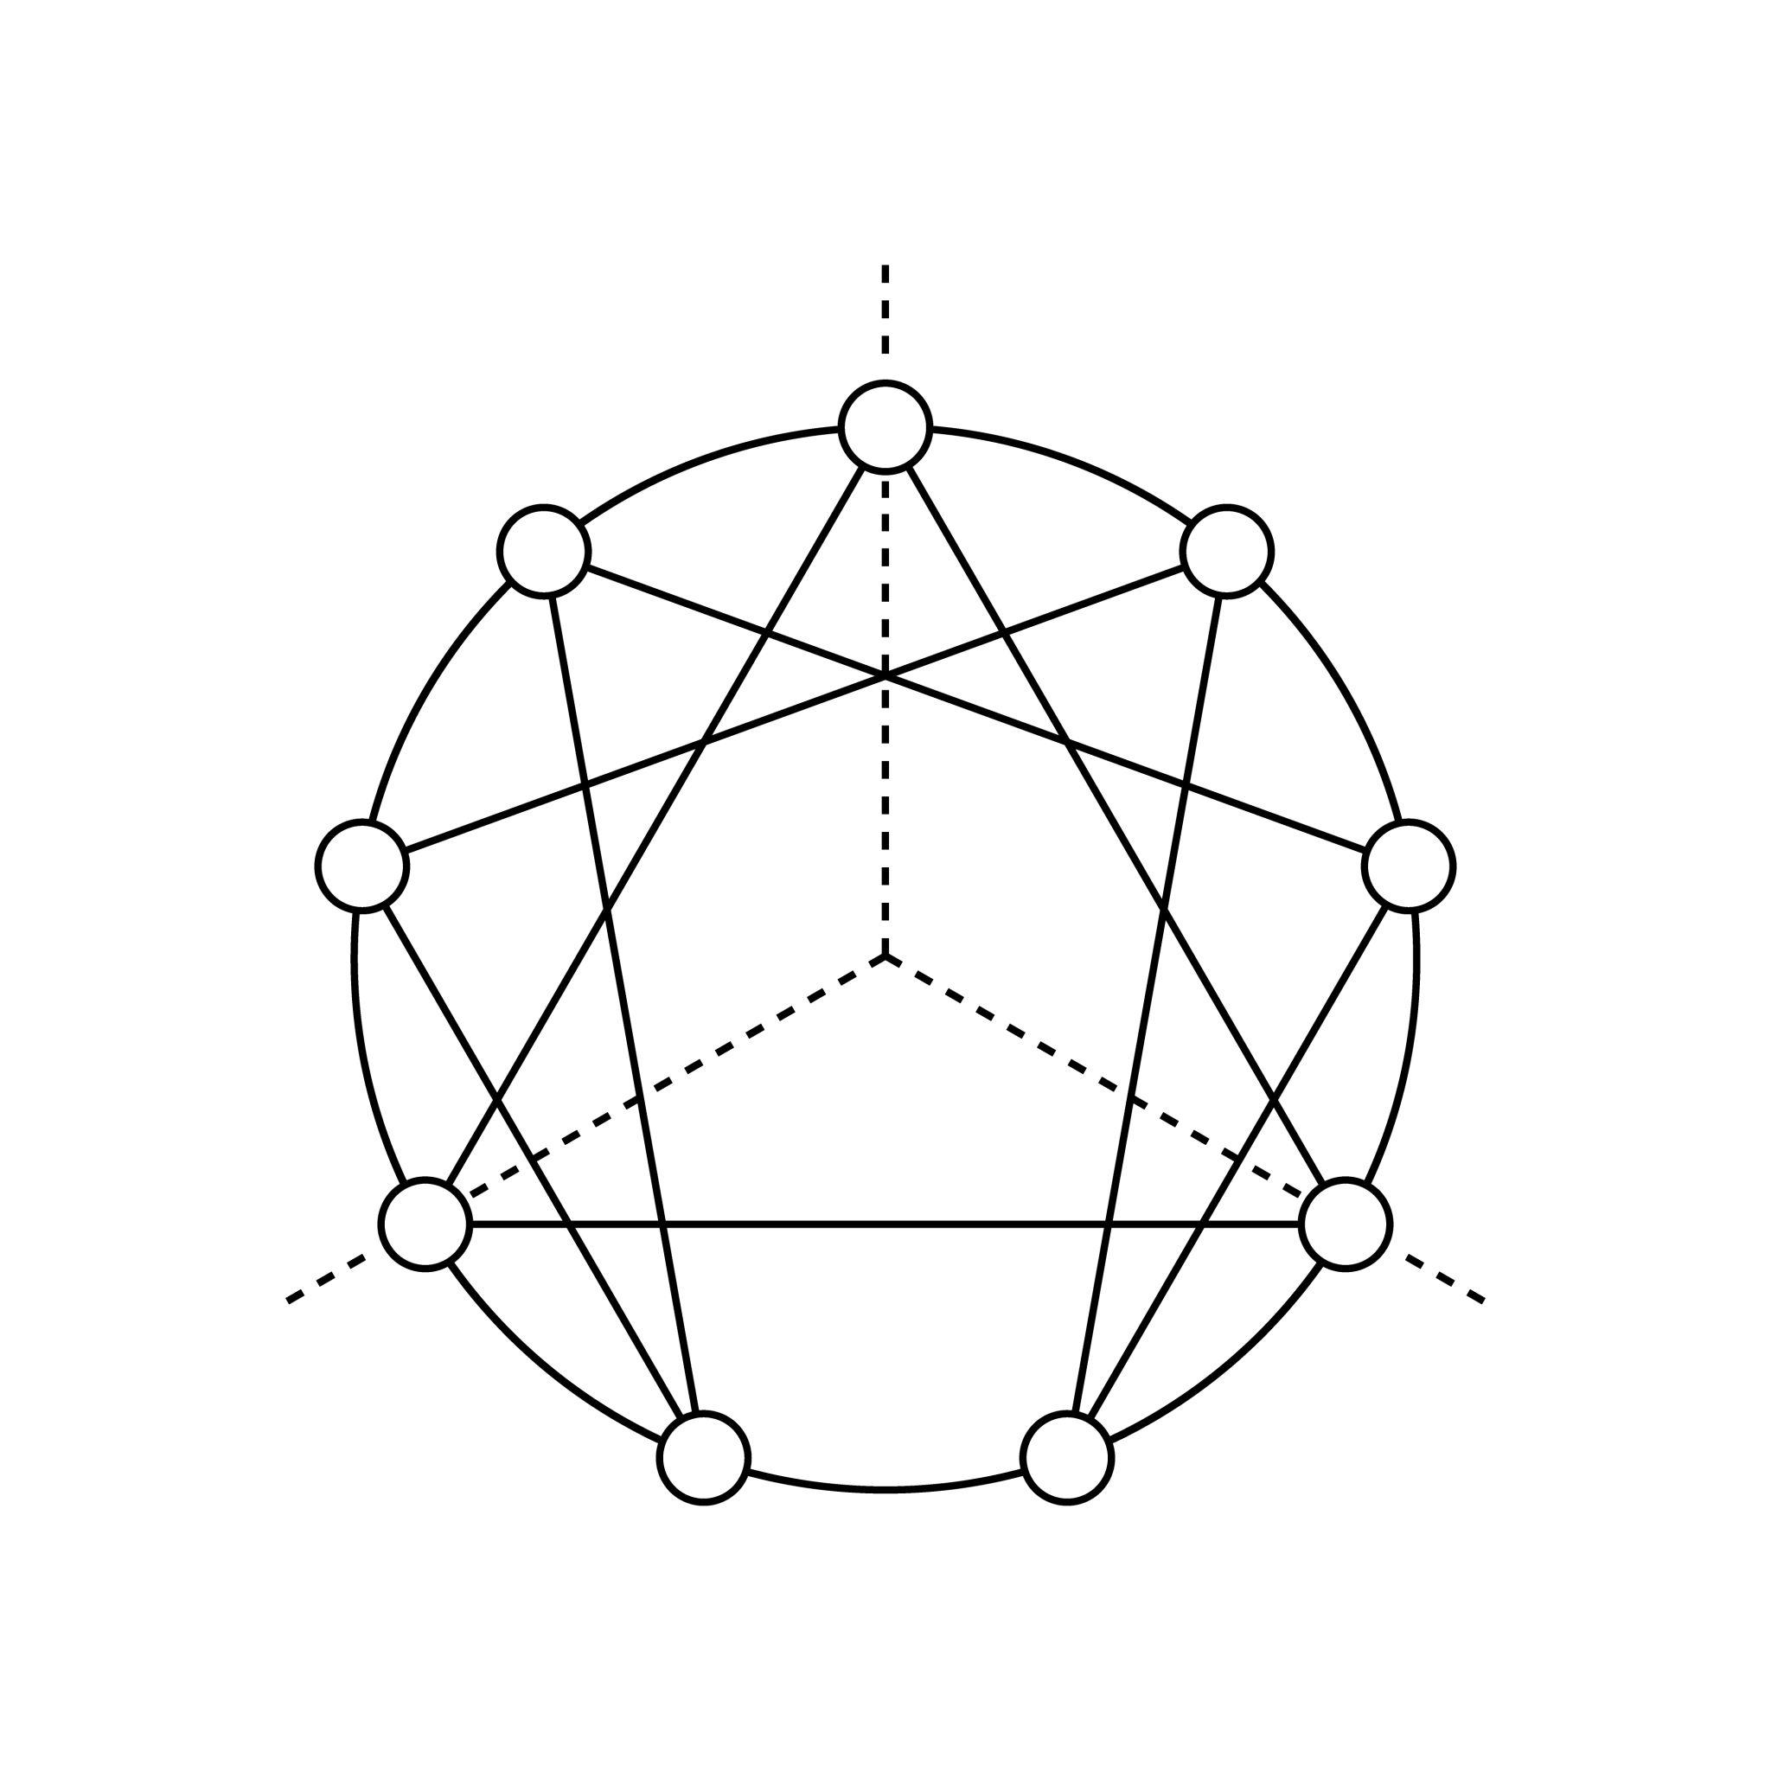

Key Points
# Source: AI Source: Provided by: [Data Path: Persons Table -> ID Column: 1, Name_En Column: Motasem Essam] -> From: [ChatGPT] on [7/25/2026]
- The Enneagrammic Rotunda belongs to the Star-Rotunda family.
- Its defining arrangement is a nine-pointed star.
- Its documented star-polygon form is $\{9/2\}$.
- It is different from the ordinary Nonagonal Rotunda.
- Its three-dimensional face composition should be distinguished from the properties of the two-dimensional enneagram.

Main Classification
# Source: AI Source: Provided by: [Data Path: Persons Table -> ID Column: 1, Name_En Column: Motasem Essam] -> From: [ChatGPT] on [7/25/2026]
Solid Geometry
└── Types of Solids
└── Star-Rotundas
└── Types of Star-Rotundas
└── Enneagrammic Rotunda
└── Enneagrammatic Arrangement
└── Enneagram {9/2}

Conclusion
# Source: AI Source: Provided by: [Data Path: Persons Table -> ID Column: 1, Name_En Column: Motasem Essam] -> From: [ChatGPT] on [7/25/2026]
The Enneagrammic Rotunda is a specialized Star-Rotunda characterized by a nine-pointed star arrangement. Its documented model uses the star-polygon notation $\{9/2\}$, distinguishing it from ordinary nonagonal-based rotundas.
Reference: <Link ref="turn336288search7" title="Enneagrammic Rotunda – Wikimedia Commons"/>.

